**Analysis of the relative performance of stocks  
based on their historical returns using LSTM**

20201036 Moolkyeol Kim

**I. Introduction**

Learning neural networks in class and a lot of research on momentum, we were curious about the scoring method that could capture the nonlinear relationship of past returns. This project aims to create a model that better follows future stock returns while reflecting the nonlinear relationship between past stock returns using LSTM rather than the linear momentum weighting scheme proposed by Xiong et al.

**II. Related Literature**

- Momentum, Acceleration, and Reversal

Xionga et al, 2015 published a study on acceleration momentum that reflects the acceleration and reversal of stock returns and confirmed its superior effect compared to the existing momentum factor.

**III. Method**

1. Data

1) CRSP stock return dataset provided in class.

2) Monthly Market Equity of U.S. Stocks provided in class. (For value-weighted portfolio construction)

2. Portfolio Scoring

We refer to portfolio of consideration as “JK Portfolio”. J is look back period and K is holding period. First, we filtered only stocks that have data (past 12m returns, market cap) for past year from time t. Next, several types of portfolio scoring have been performed.

1. PR1YR Momentum

$PR1YR momentum =\left\{\prod_{i=2}^{12}{\left(1+r_{t-i}\right)}\right\} -1$ (1)

PR1YR is a factor-mimicking portfolio for one-year return momentum. It assumes that stocks that have risen a lot over the past 11 months, excluding the previous month, will also rise a lot over the next month. $r_{t-i}$ is monthly return from month 𝑡−𝑖 to 𝑡−𝑖+1.

1. Acceleration Momentum

Acceleration momentum gives weight to the previous returns.

$Acceleration momentum=\sum_{i=1}^{12}{w_{i}r_{t-i}}$ (2)

 Fig 1. Step Function weighting

Step Function simply puts weight of ‘+1’ to the most recent 6 months (lag-1 through lag-6) and weight of ‘-1’ to the second recent 6 months (lag-7 through lag-12). We used Step Function weighting scheme here.

1. LSTM Model

${\hat{r}}_{t}=LSTM(r_{t-1})$*, where $r_{t-1}$ =* {$r_{t-1}, …,r_{t-12}$} (3)

LSTM has been trained to produce future returns if returns of past 12 months is put as a vector, and portfolio is formed by reflecting prediction (future return) as score. LSTM uses forget gate to remember only some of inputs and forget the other. Thus, it deals well with long-term information. By cell state runs straight down entry chain and goes through forget gate, input gate, and output gate, nonlinear and dynamic weight can be applied.

We set the period before 2010 for training and after 2010 for testing. However, since return is like white noise, loss does not converge, and learning does not work well when learning by return itself. Therefore, ‘wealth’, cumulative of return, is predicted one month after converting return series to wealth series. Next, we converted predicted wealth to return.

3. Portfolio Construction & Weighting & Long-Short Strategy

We divided stocks with scores into 10 groups (Q1~Q10). Q1 has highest performance, Q10 lowest performance. Then we applied Long-short strategy (Q1 – Q10); Buy Q1, sell Q10.

4. Handling Missing Values

We measured performance after K=1 month in JK portfolio. If there is no return value after 1 month, -1 is assigned to future return because we judged them as delisting or suspending trading issues. Then, we rebalanced portfolio at time t+1 and repeat same process.

**IV. Analysis**

1. PR1YR Momentum

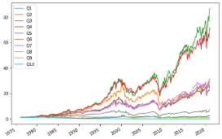

Fig 2. Result of Quantities separating & Mean return calculation using PR1YR momentum

If PR1YR momentum is predictive, the Q1-Q10 should be well separated. However, they are not well separated than expected.

2. Acceleration Momentum

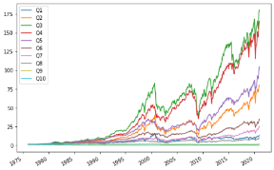

Fig 3. Result of Quantities separating & Mean return calculation using Acceleration Momentum

Q1 ~ Q10 are also not well separated than expected. However, it was better separated than PR1YR momentum, and overall rate of return is higher than before.

3. Necessity of Other Scoring Calculation Method

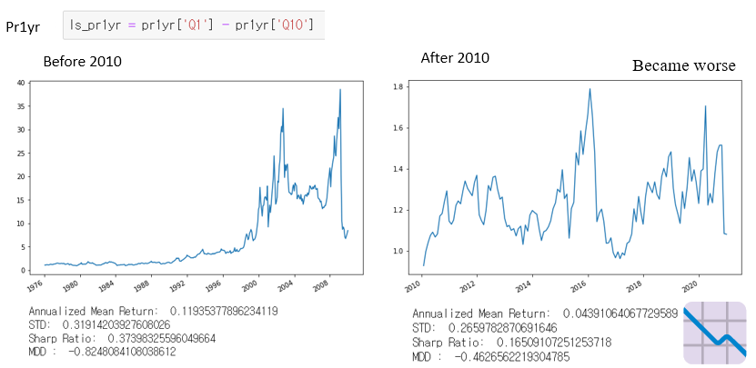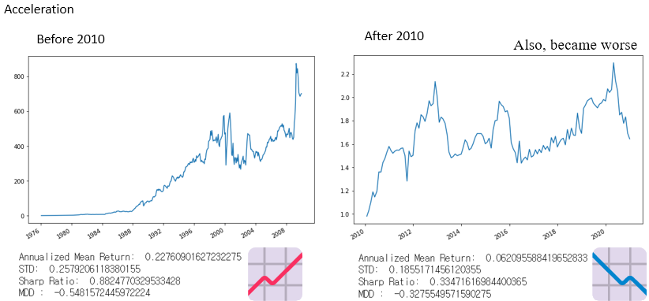

Fig 4. Result of Long minus Short (Q1-Q10) (Left: PR1YR Momentum, Right: Acceleration Momentum)

When both in PR1YR Momentum and Acceleration Momentum using, after 2010 annualized mean return decreased significantly compared to before of 2010.

According to ‘You Can't Always Trend When You Want’, momentum strategy has been losing steam after 2010 because market price movements have decreased. Thus, better results can be achieved with deep learning models that can handle sequence or time series well.

4. LSTM Model

To solve problem in 3, we used LSTM to construct portfolio. This is because LSTM can efficiently handle long sequence data, and possible to set nonlinear weights. Number of epochs were set to 150 that does not cause overfitting.

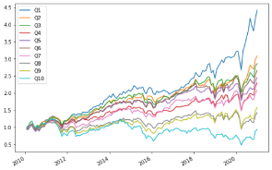

Fig 5. Result of Quantities separating & Mean return calculation using LSTM (number of epochs = 150) in test period (after 2010)

Even during the test period (after 2010), Q1~ Q10 are well distinguished significantly.

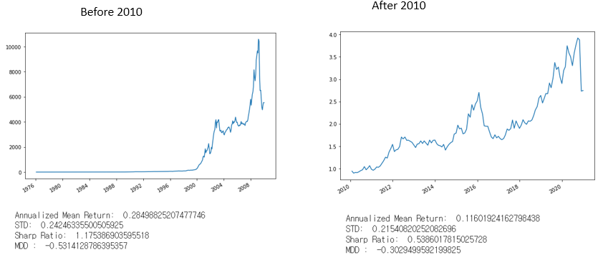 

Fig 6. Result of Long-Short

Annualized Mean Return didn’t have fallen a lot after 2010 compared to before 2010.

**V. Conclusion**

We calculated score and constructed portfolio using 3 scoring calculation methods: PR1YR, Acceleration, and LSTM. When PR1YR Momentum and Acceleration Momentum were used, Q1-Q10 was not well separated (not predictive). And since market price movements have decreased after 2010, momentum strategies showed sluggish performance. So we felt need for a new model that could predict future returns by capturing nonlinear relationships in the past returns. Therefore, LSTM that can apply dynamic and non-linear weight was used. Then Q1~Q10 was well separated even in test period (after 2010).

We then applied long minus short (Q1-Q10).

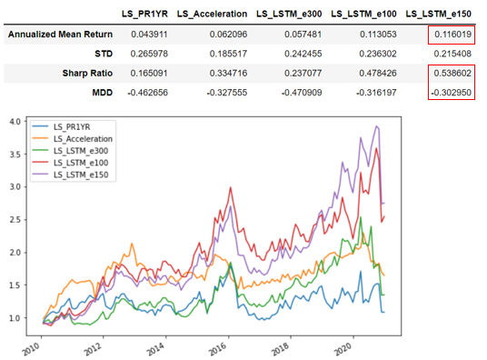 Fig 7. Summary of long minus short (Q1-Q10) in test period (After 2010)

When LSTM (epochs 150) was used, Annualized Mean Return was the highest. Performance of the momentum strategies (PR1YR momentum, Acceleration momentum) in after 2010 was sluggish, but this could be improved using LSTM.

We wanted to try using more timesteps to predict future return such as 24 months, and try rolling train and test method for further studies. Portfolio optimization requires expected return model that predicts future return. Our study suggests it can be predicted using LSTM.

**VI. Reference**

* Jegadeesh & Titman. (1993). Returns to Buying Winners and Selling Losers: Implications for Stock Market Efficiency. The Journal of Finance Vol. 48, No. 1 (Mar., 1993), pp. 65-91

* Xiong, James & Ibbotson, Roger. (2015). Momentum, Acceleration, and Reversal. The Journal Of Investment Management. 13. 1-12.

* Hou, Kewei and Xue, Chen and Zhang, Lu, Replicating Anomalies (June 12, 2017). Fisher College of Business Working Paper No. 2017-03-010, 28th Annual Conference on Financial Economics and Accounting, Charles A. Dice Center Working Paper No. 2017-10, Available at SSRN: https://ssrn.com/abstract=2961979 or <http://dx.doi.org/10.2139/ssrn.2961979>

* Abhilash BabuAri LevineYao Hua OoiSarah SchroederErik Stamelos (April 23, 2019). You Can't Always Trend When You Want. AQR, Available at <https://www.aqr.com/Insights/Research/Journal-Article/You-Cant-Always-Trend-When-You-Want>